**Product Discount Management**

Set Up Your Development Environment

* **Java Development Kit (JDK)**: Version 21
* Maven : Dependency management tool
* **IDE**: IntelliJ IDEA, Eclipse, or VS Code to run the project. (Spring-boot set in this IDE’s or you can use Spring Tool Suit).

Database setup

In application properties, provided all the details require to make connection with either h2 database (Inbuild database provided by springboot) or you can manually install postgress and create database - discountmanager and set your username and password.

1. To connect with h2 database

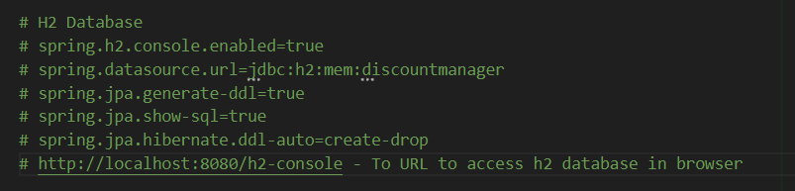

Use URL to access h2 database after running application –

http://localhost:8080/h2-console

1. To connect with Postgress Sql

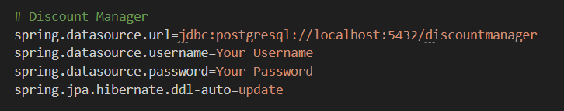

Endpoints-

To add product

localhost:8080/product/add

To add product for ex. -

{

        "name": "Bluetooth Headphones",

        "price": 100.00,

        "quantity": 50

}

Test Cases –

1. When someone tries to add product with zero quantity, it will show 400 Bad Request becase of validation (@Positive) provided.

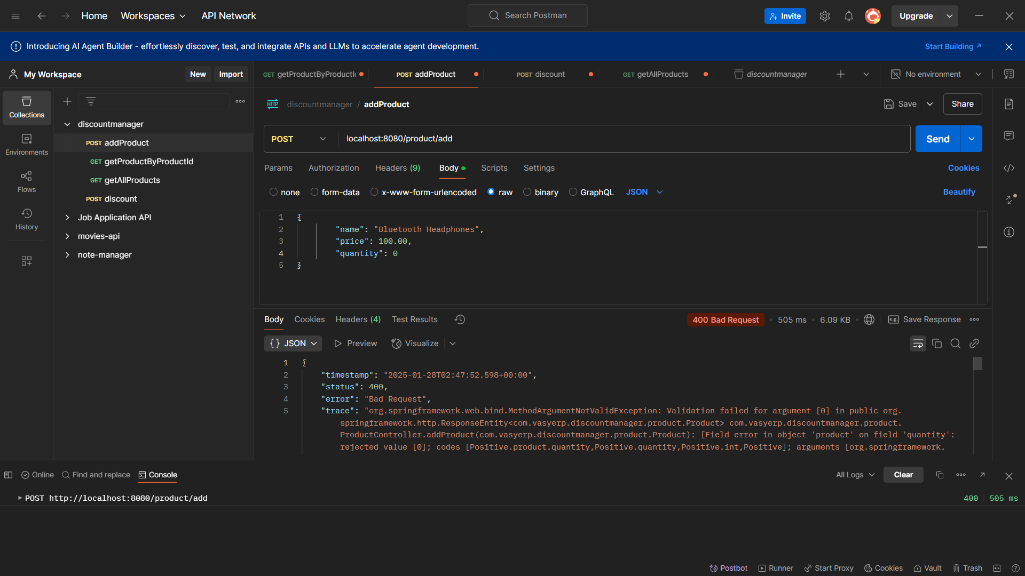

1. To add product successful fill the data as shown in the below image and the data about the product will get added in database and http status 201 created will be shown

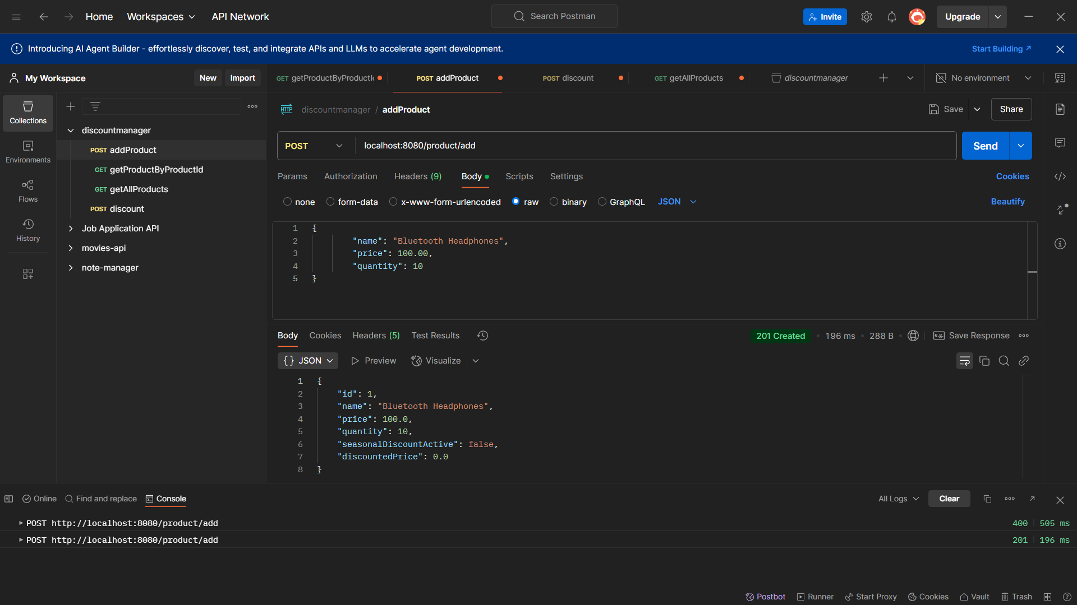

1. Add null values –

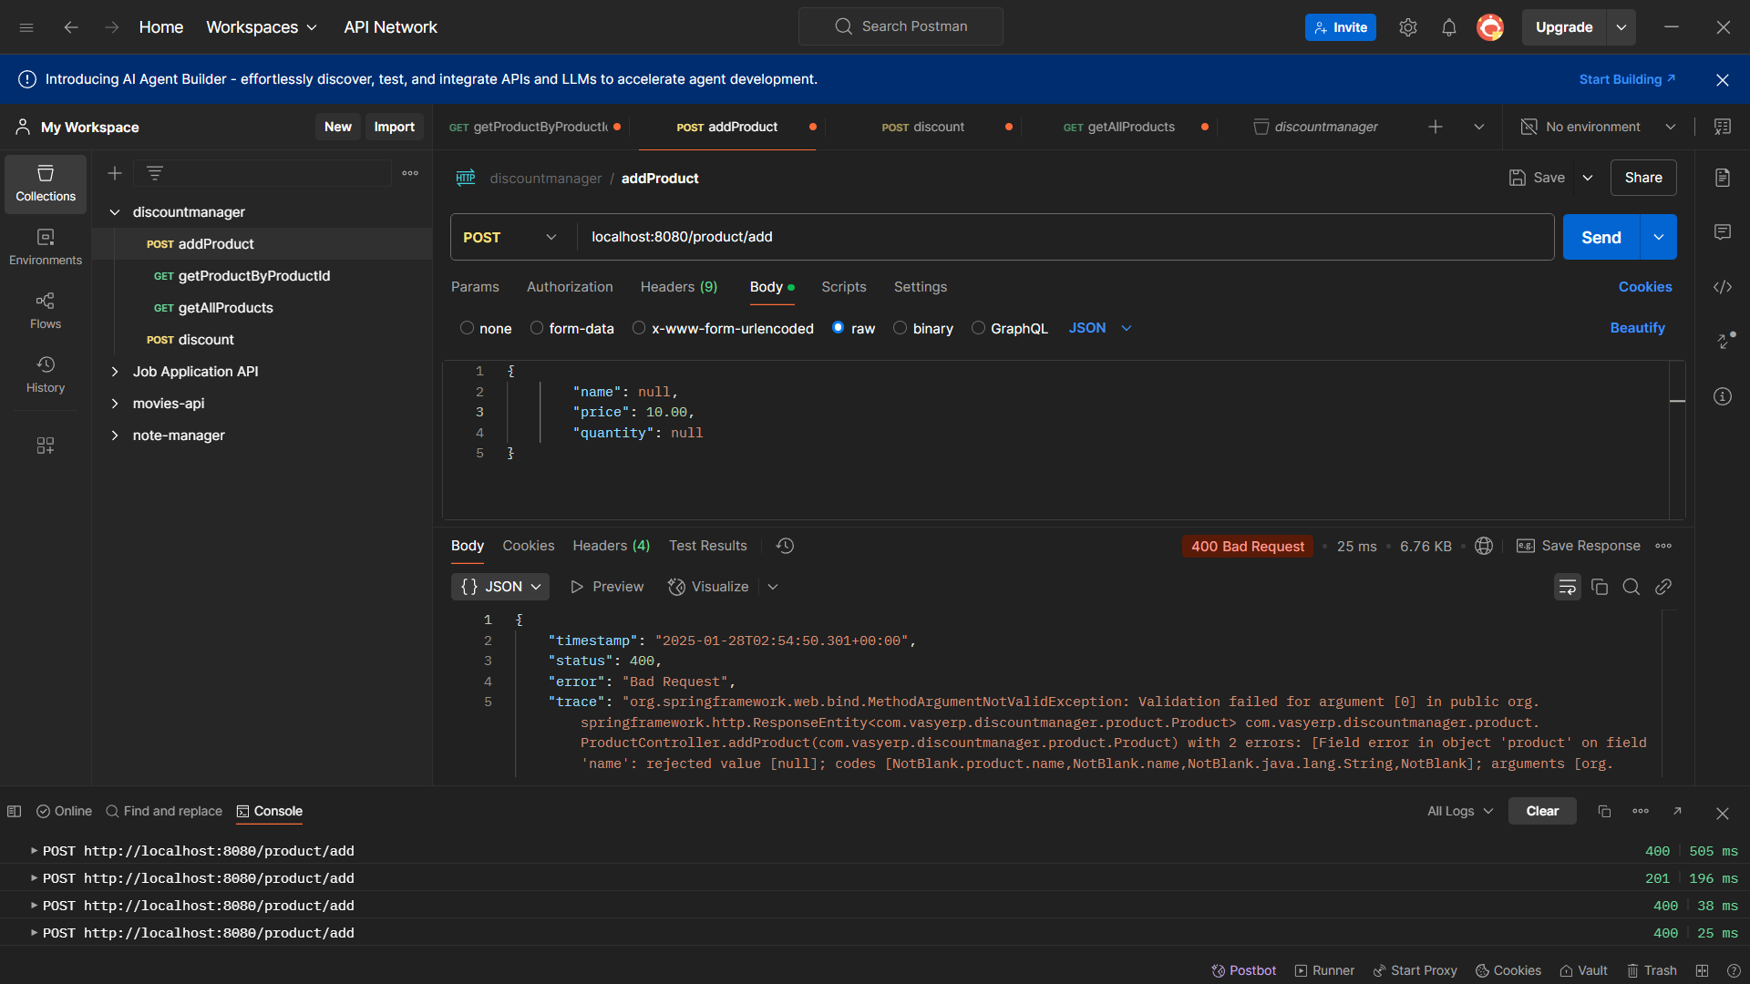

1. Product Name is Missing or Empty - Name cannot be blank

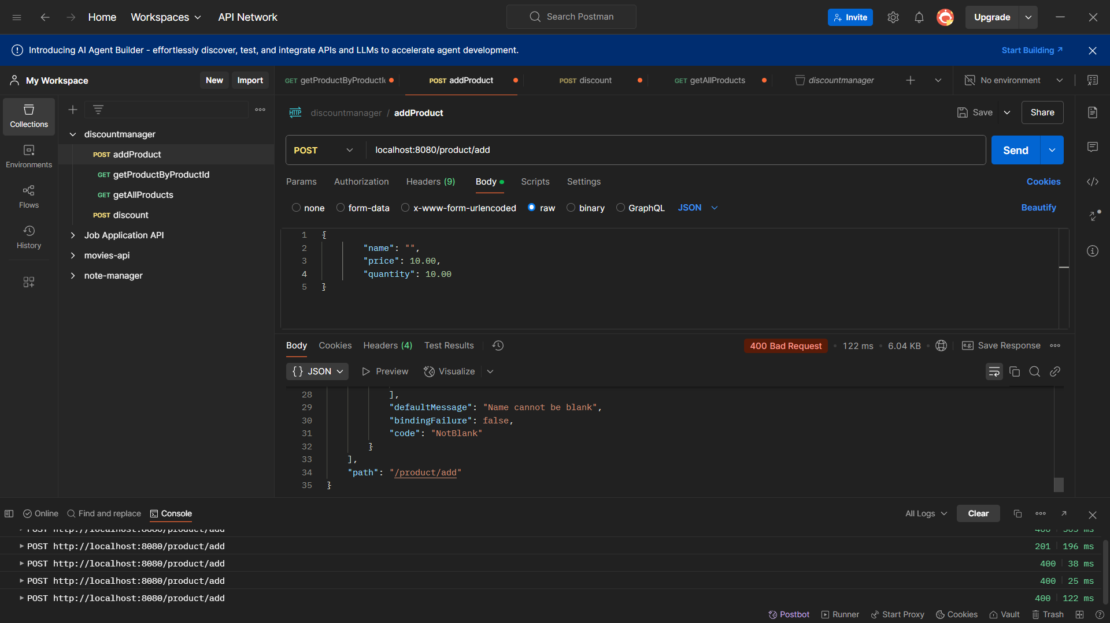

1. Price is Missing or Negative –

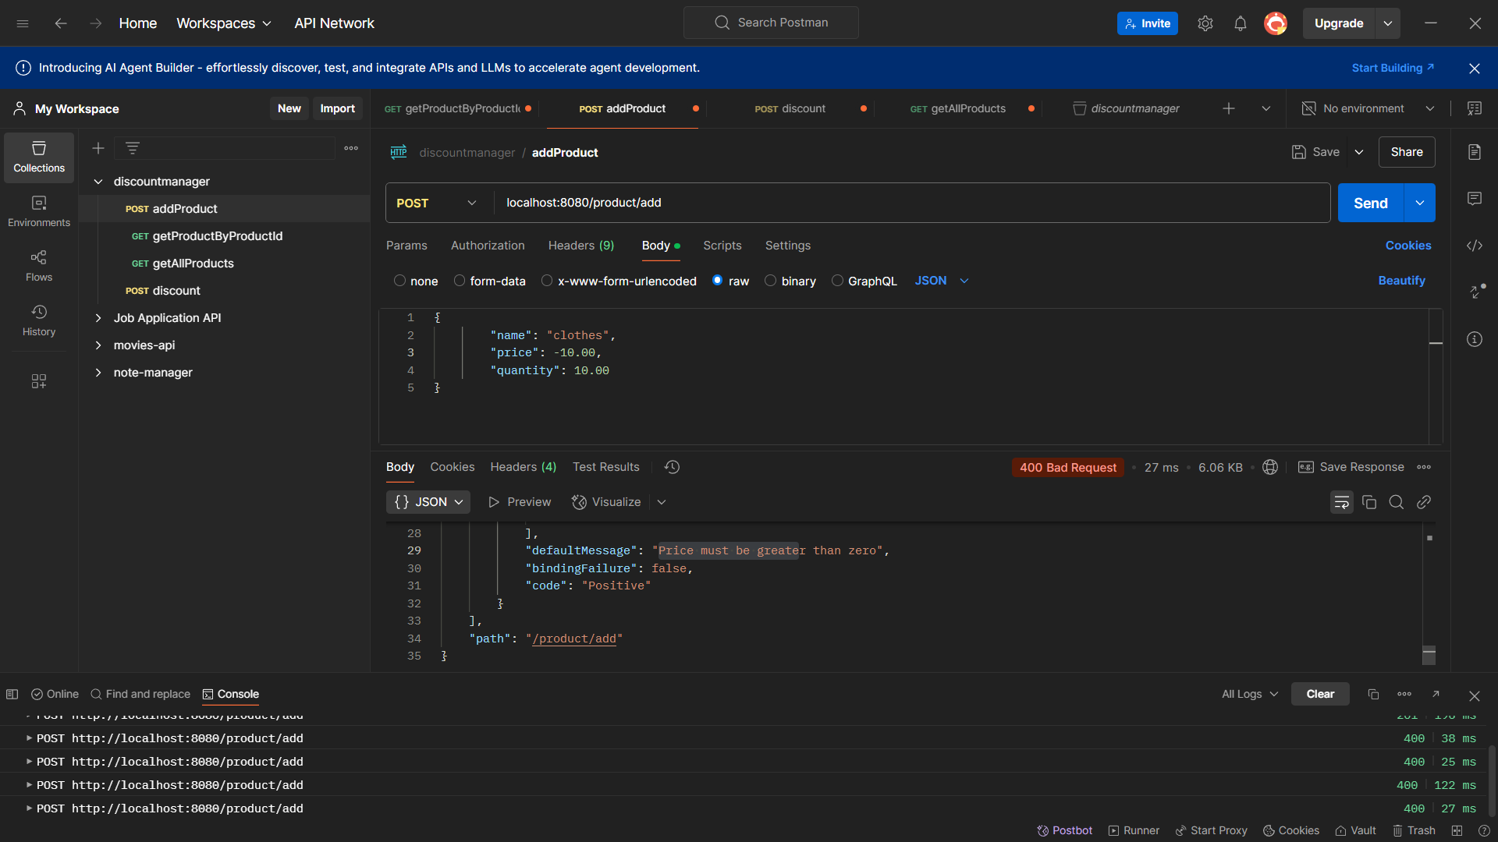

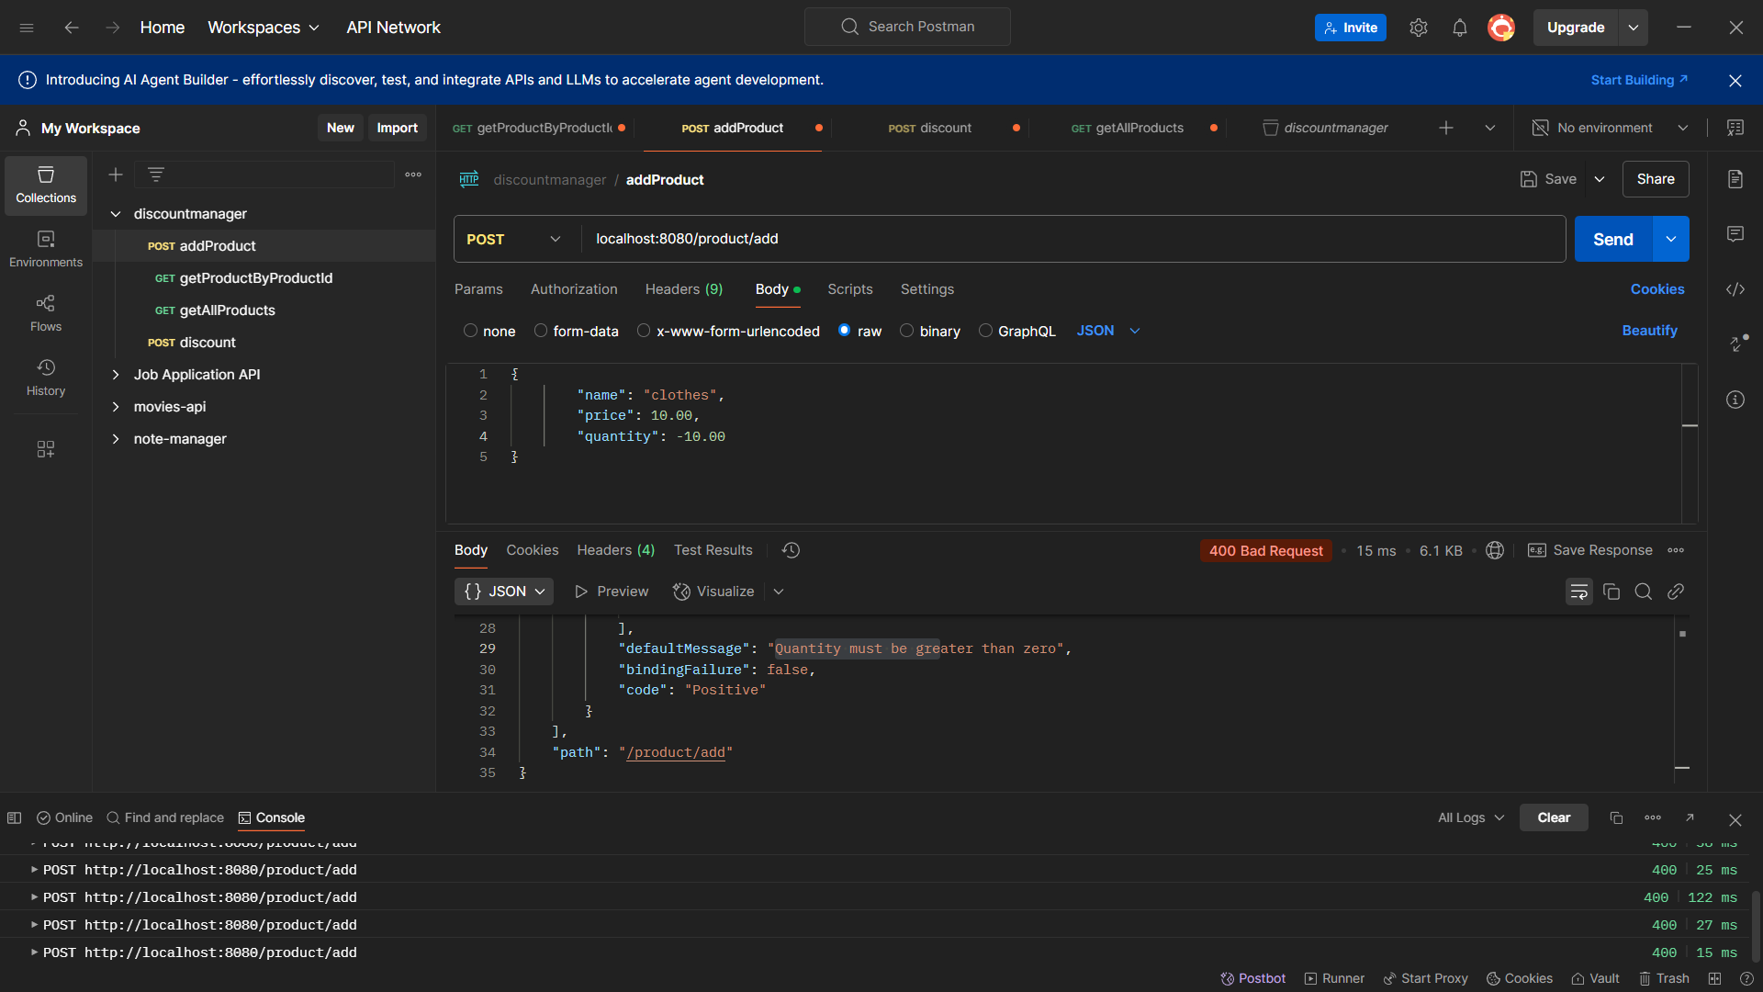

1. Invalid or Empty Request Body

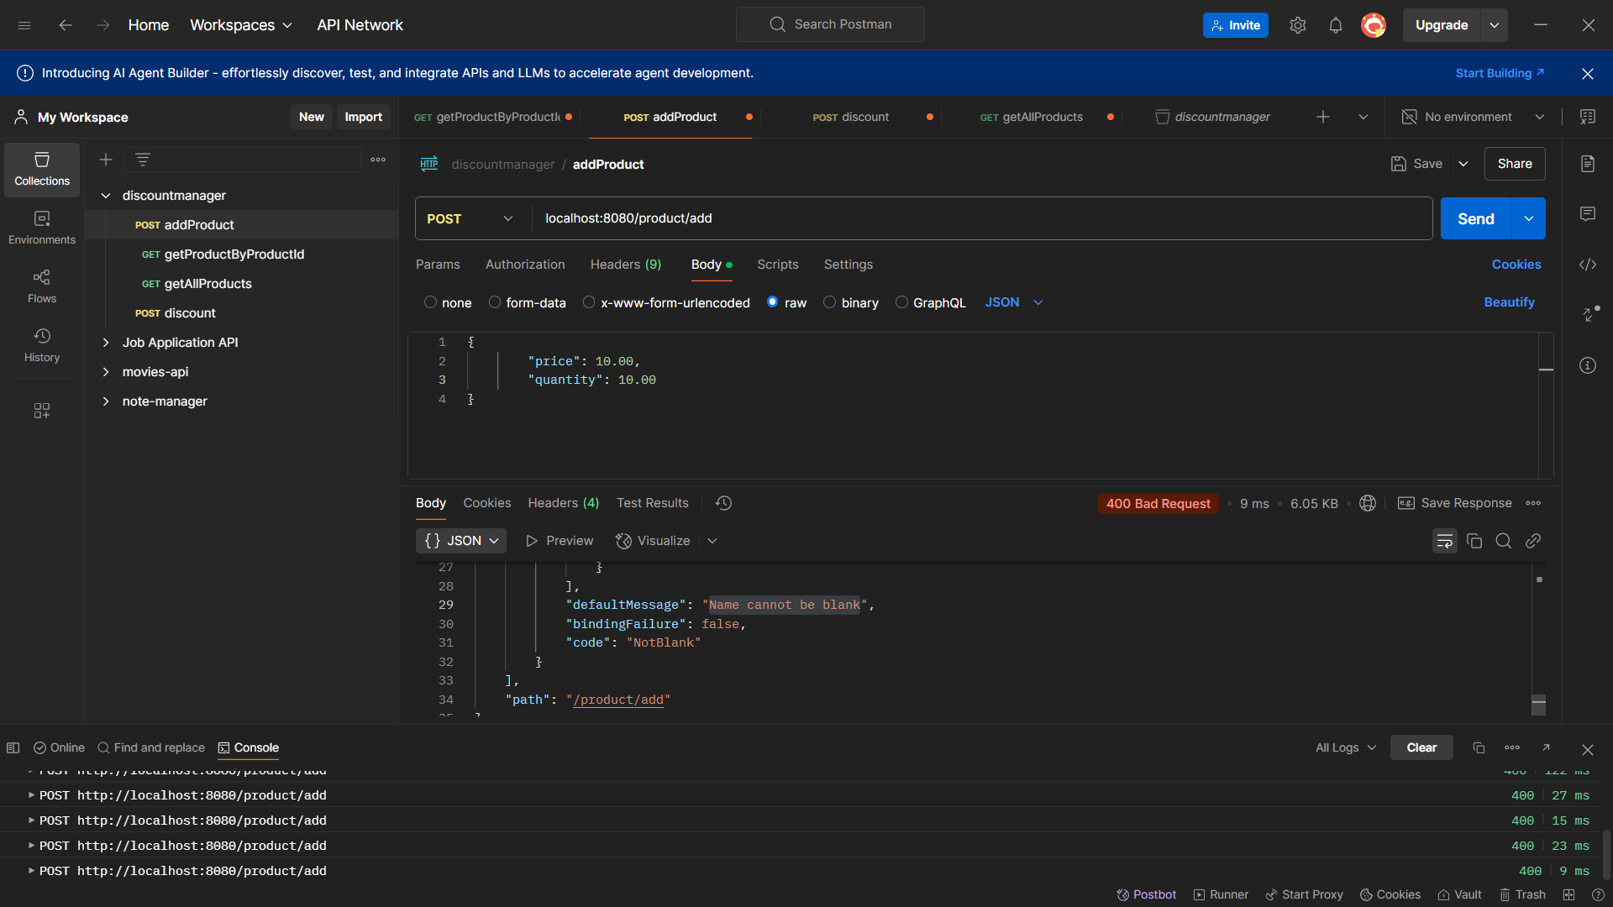

1. Zero Price or Stock

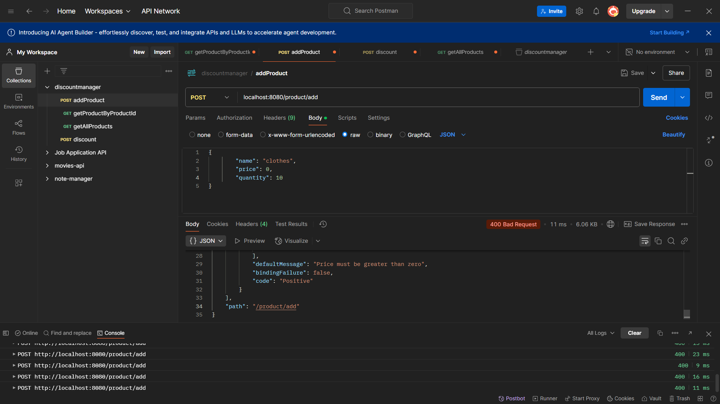

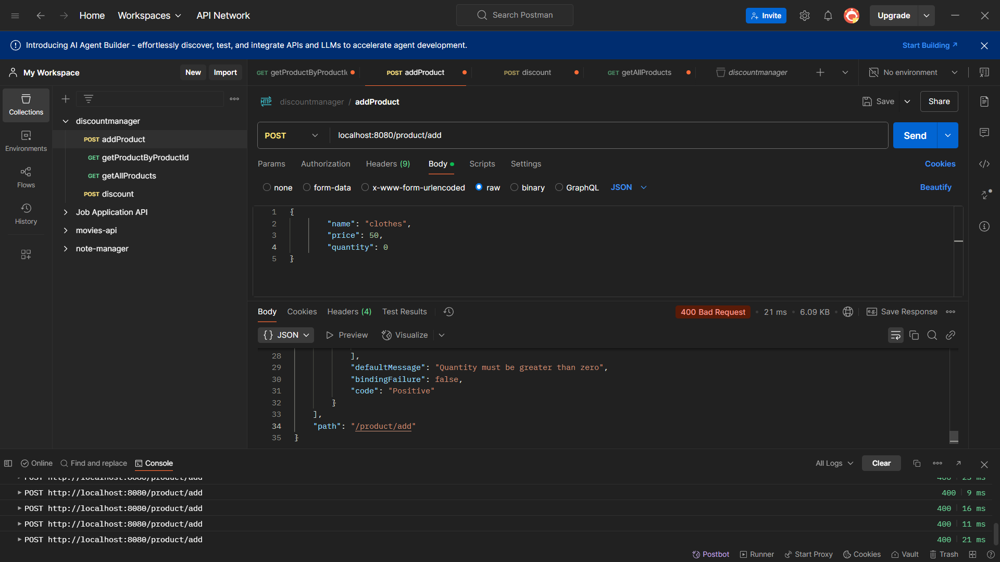

**Discount Endpoint -**

localhost:8080/product/discount

### Example 1: Update a product with a seasonal discount

```json

{

    "productId": 1,

    "discountType": "flat",

    "discountValue": 15.0,

    "seasonalDiscountActive": true

}

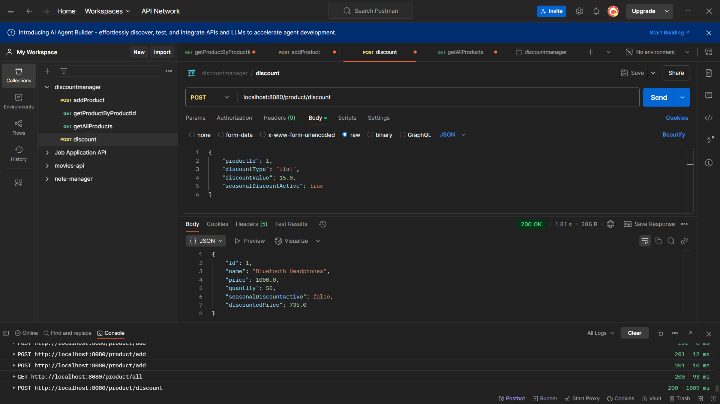

### Example 2: Update a product with a percentage discount

```json

{

    "productId": 2,

    "discountType": "percentage",

    "discountValue": 10.0,

    "seasonalDiscountActive": false

}

```

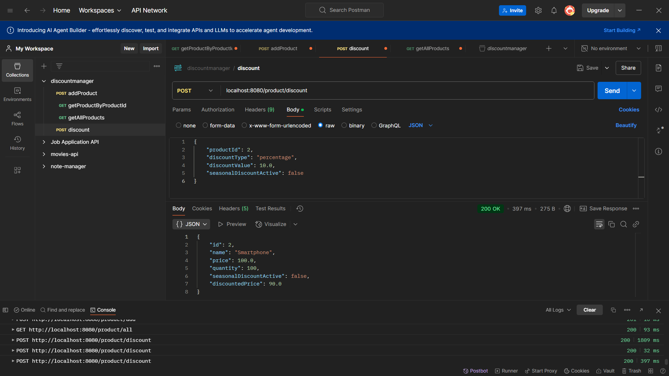

### Example 3: Update a product with a percentage discount and a seasonal discount

```json

{

    "productId": 3,

    "discountType": "percentage",

    "discountValue": 10.0,

    "seasonalDiscountActive": true

}

```

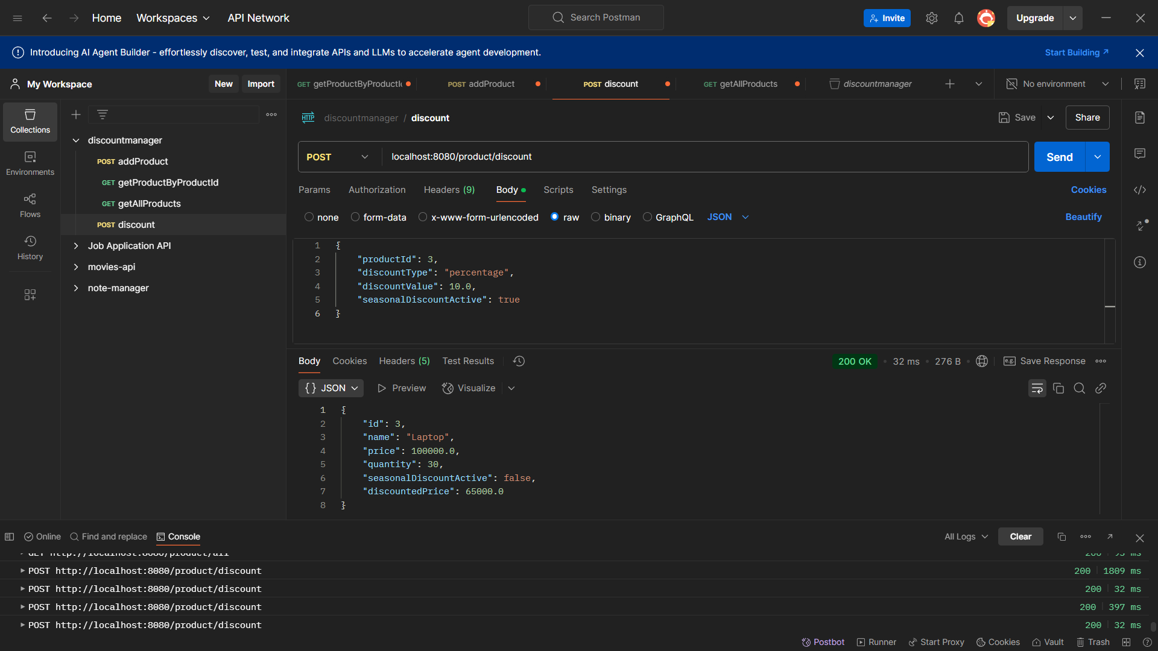

1. Discount type must be either 'percentage' or 'flat'

### Example 4: Update a product with no discount

```json

{

    "productId": 4,

    "discountType": "none",

    "discountValue": 0.0,

    "seasonalDiscountActive": false

}

```

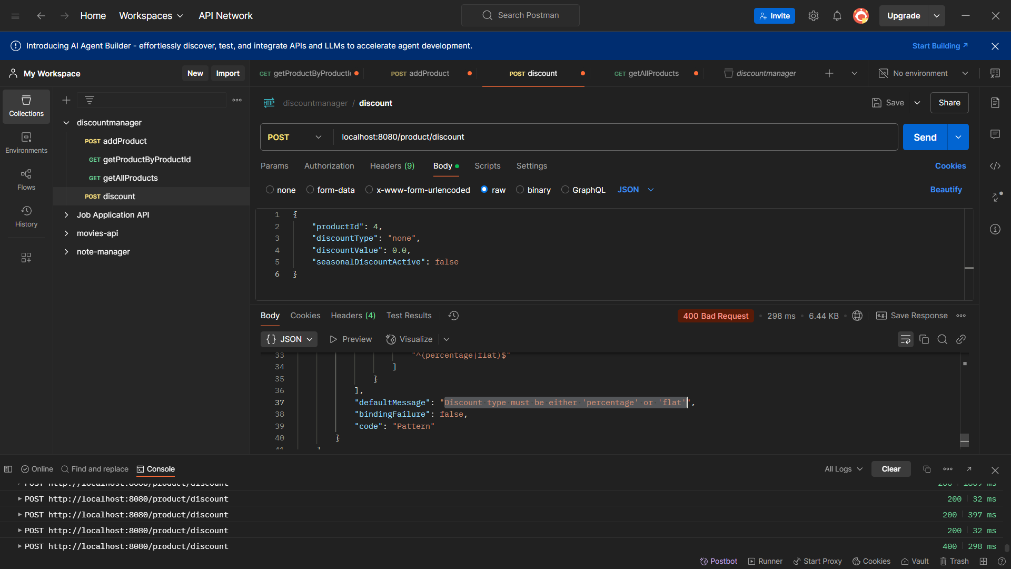

### Example 5: Update a product with a seasonal discount and no discount value

```json

{

    "productId": 5,

    "discountType": "flat",

    "discountValue": 0.0,

    "seasonalDiscountActive": true

}

```

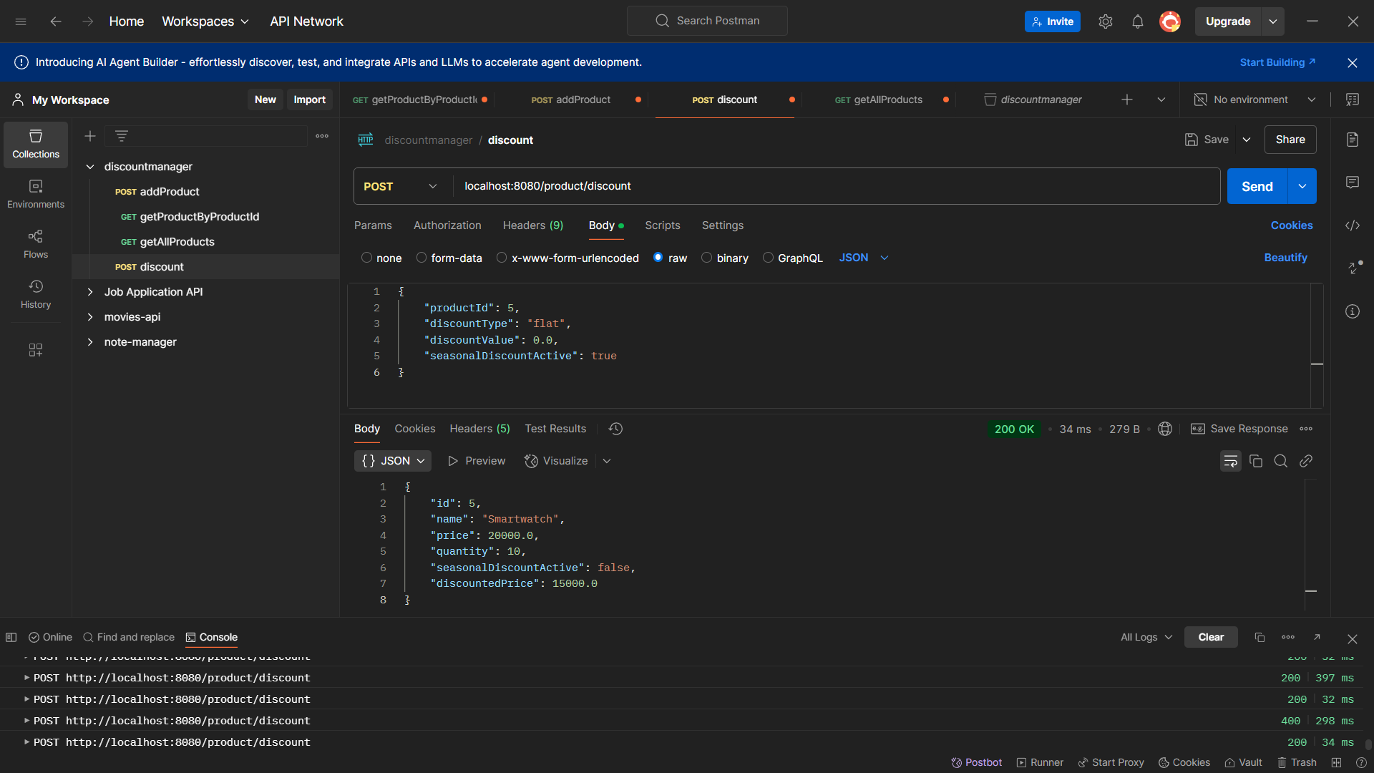

### Example 6: Update a product with a percentage discount and no discount value

```json

{

    "productId": 6,

    "discountType": "percentage",

    "discountValue": 0.0,

    "seasonalDiscountActive": false

}

```

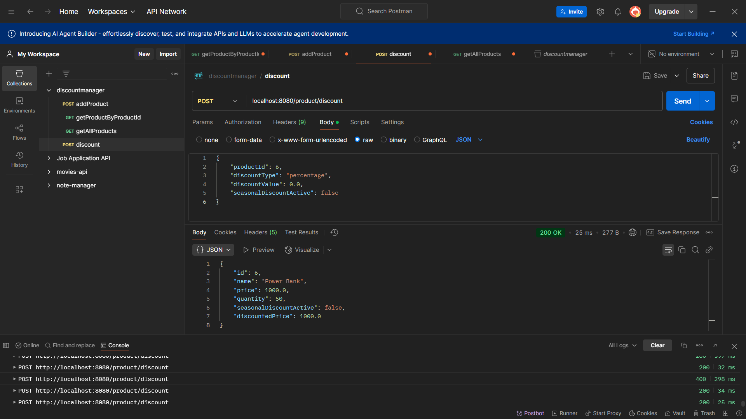

### Example 7: Update a product with a percentage discount, a seasonal discount and no discount value

```json

{

    "productId": 7,

    "discountType": "percentage",

    "discountValue": 0.0,

    "seasonalDiscountActive": true

}

```

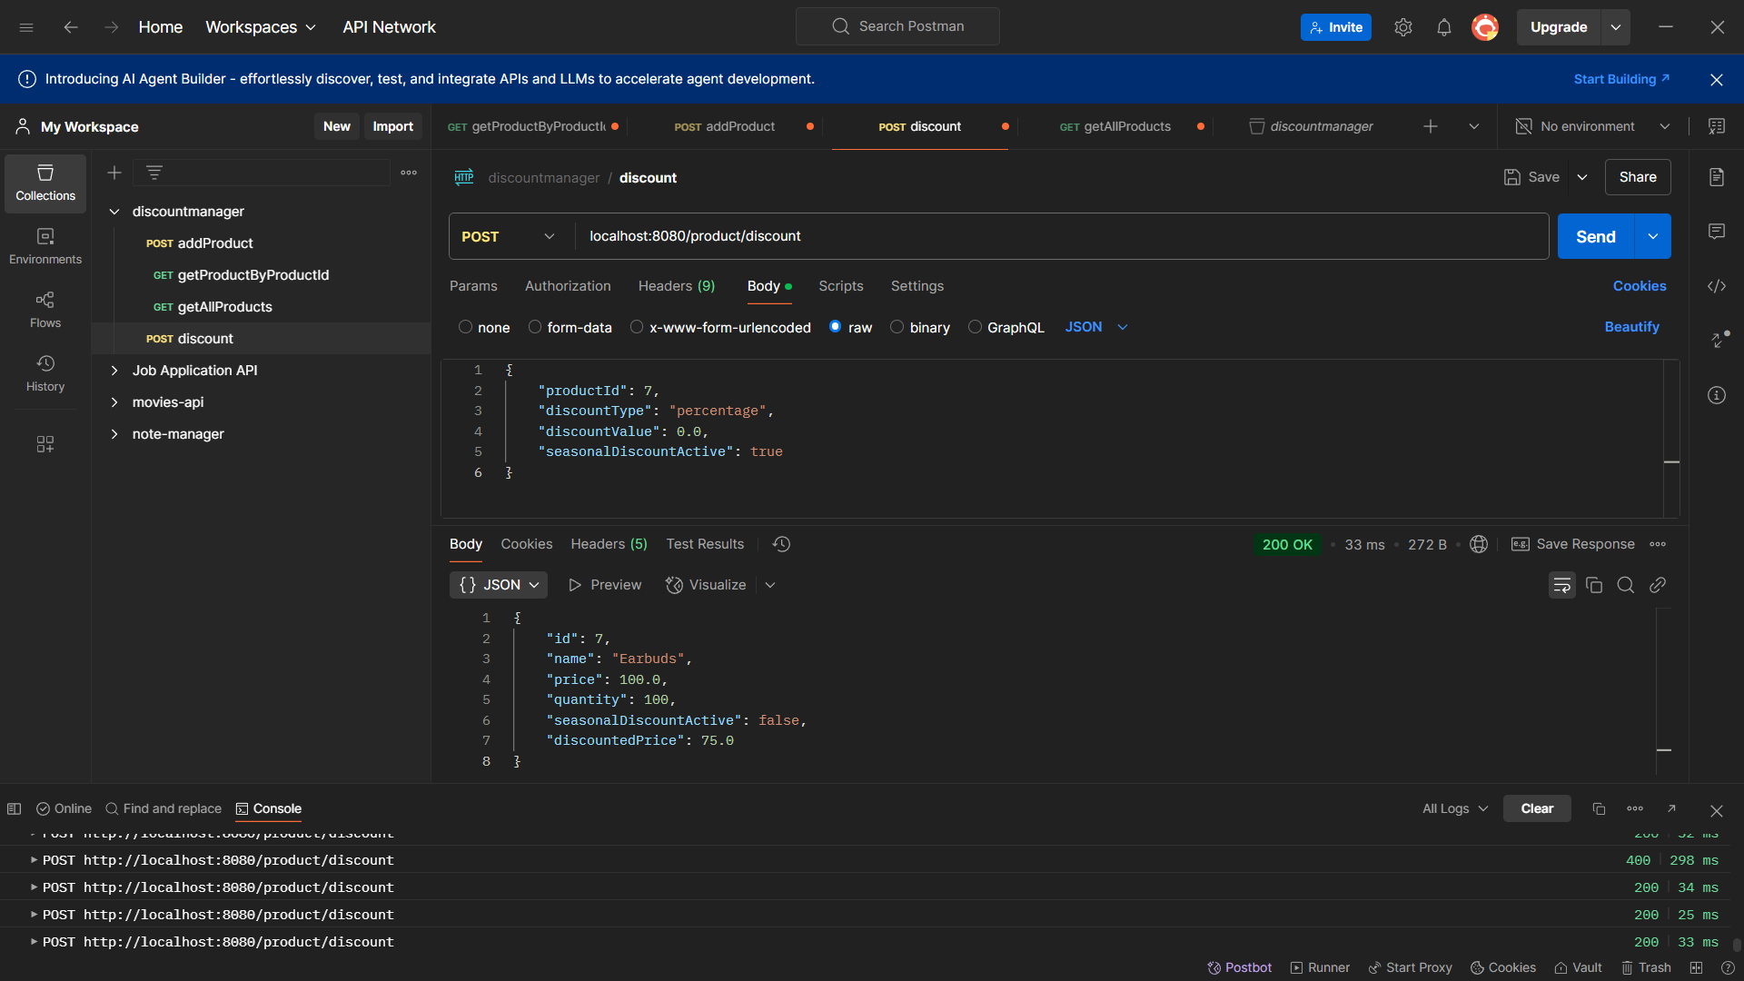

### Example 8: Update a product with a flat discount and no discount value

```json

{

    "productId": 8,

    "discountType": "flat",

    "discountValue": 0.0,

    "seasonalDiscountActive": false

}

```

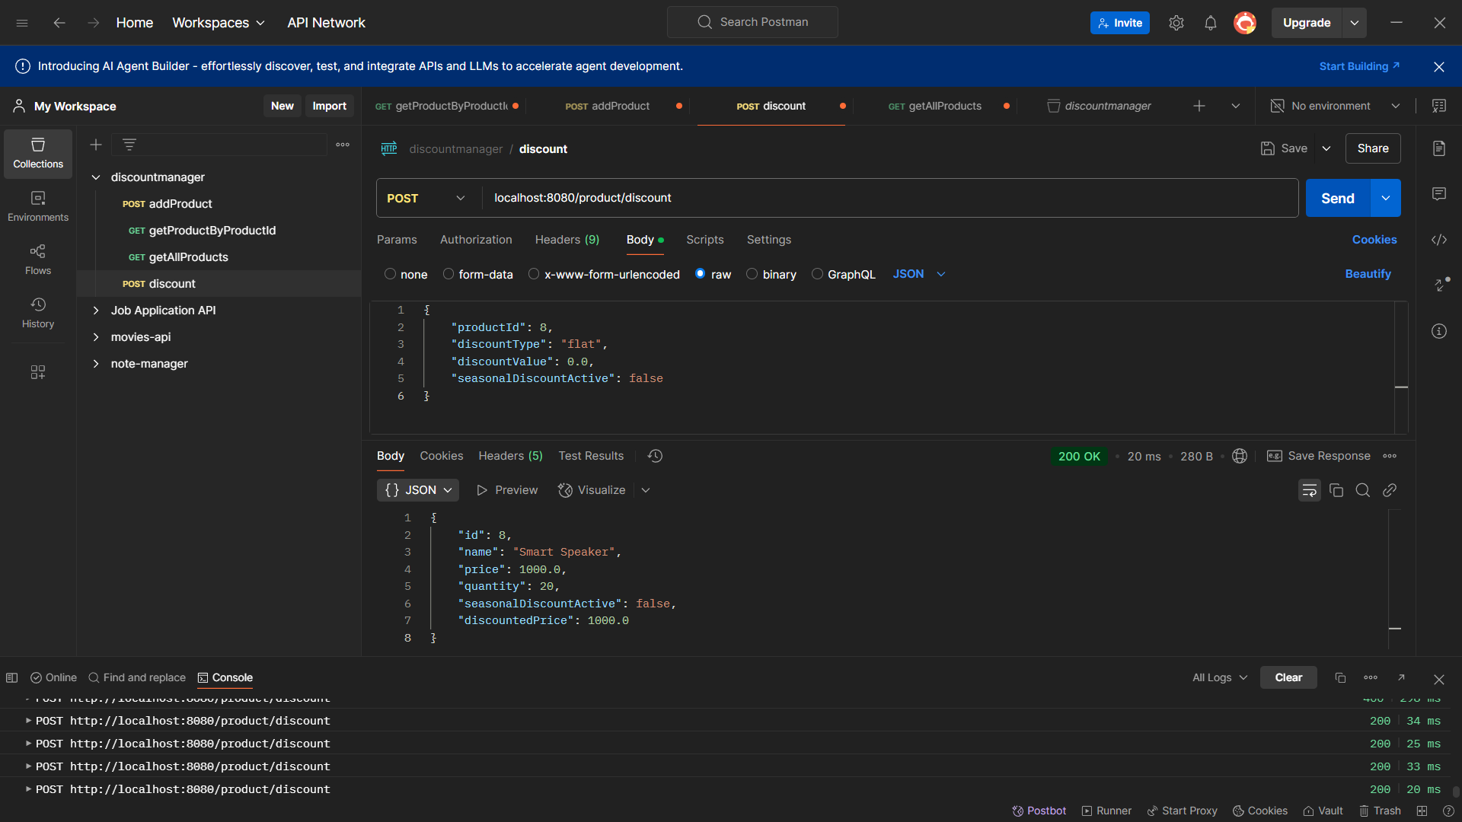

Ensure the final price is never negative. If the calculated discount exceeds the product price, set the price to zero

{

    "productId": 8,

    "discountType": "flat",

    "discountValue": 1100.0,

    "seasonalDiscountActive": false

}

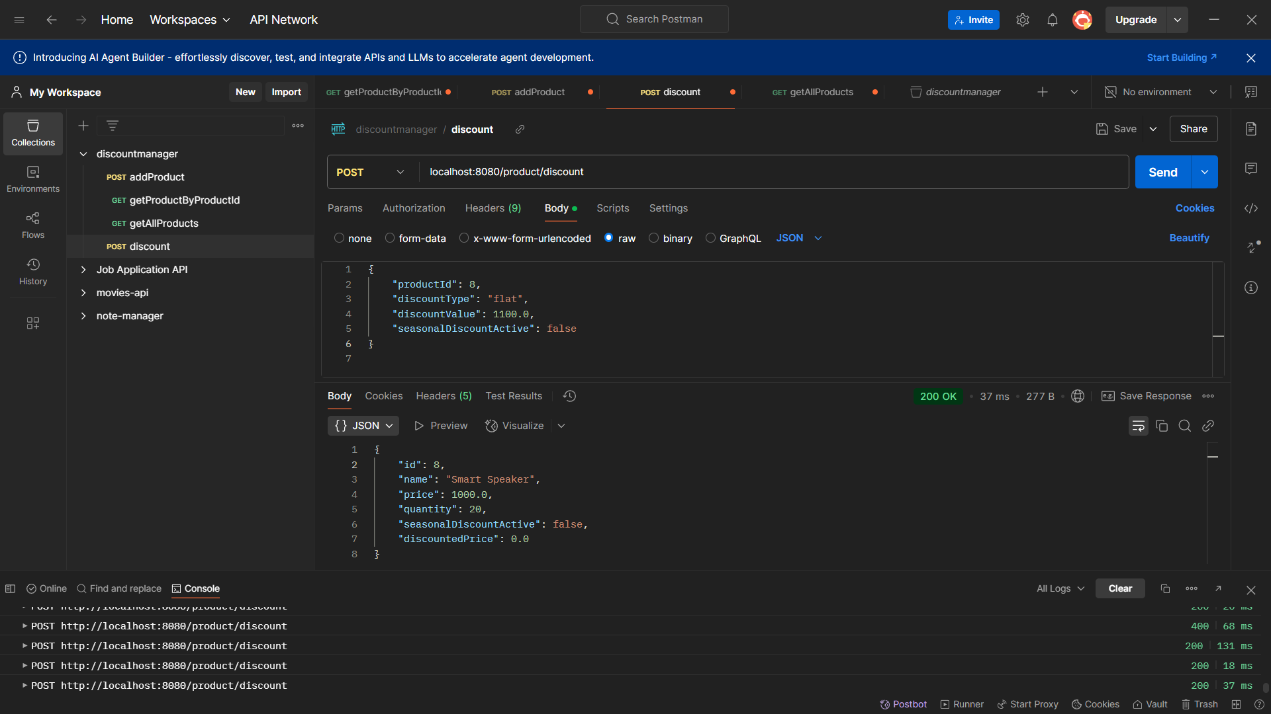

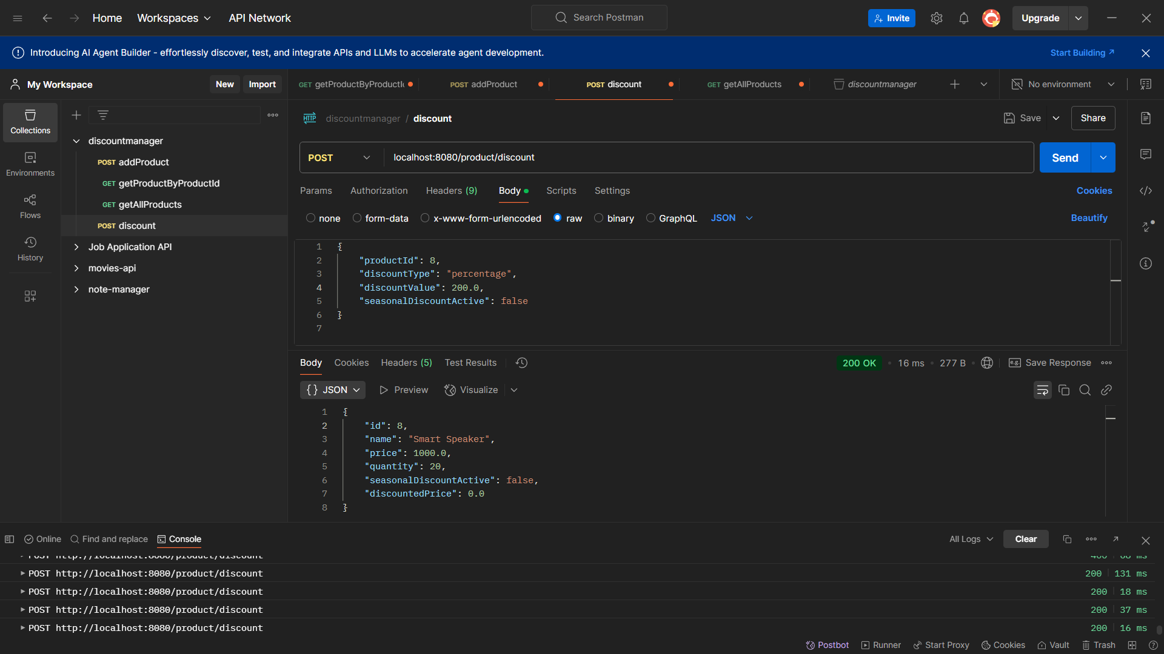

Get Product By Product Id

localhost:8080/product/{productid}

localhost:8080/product/1

Get Product By providing id -

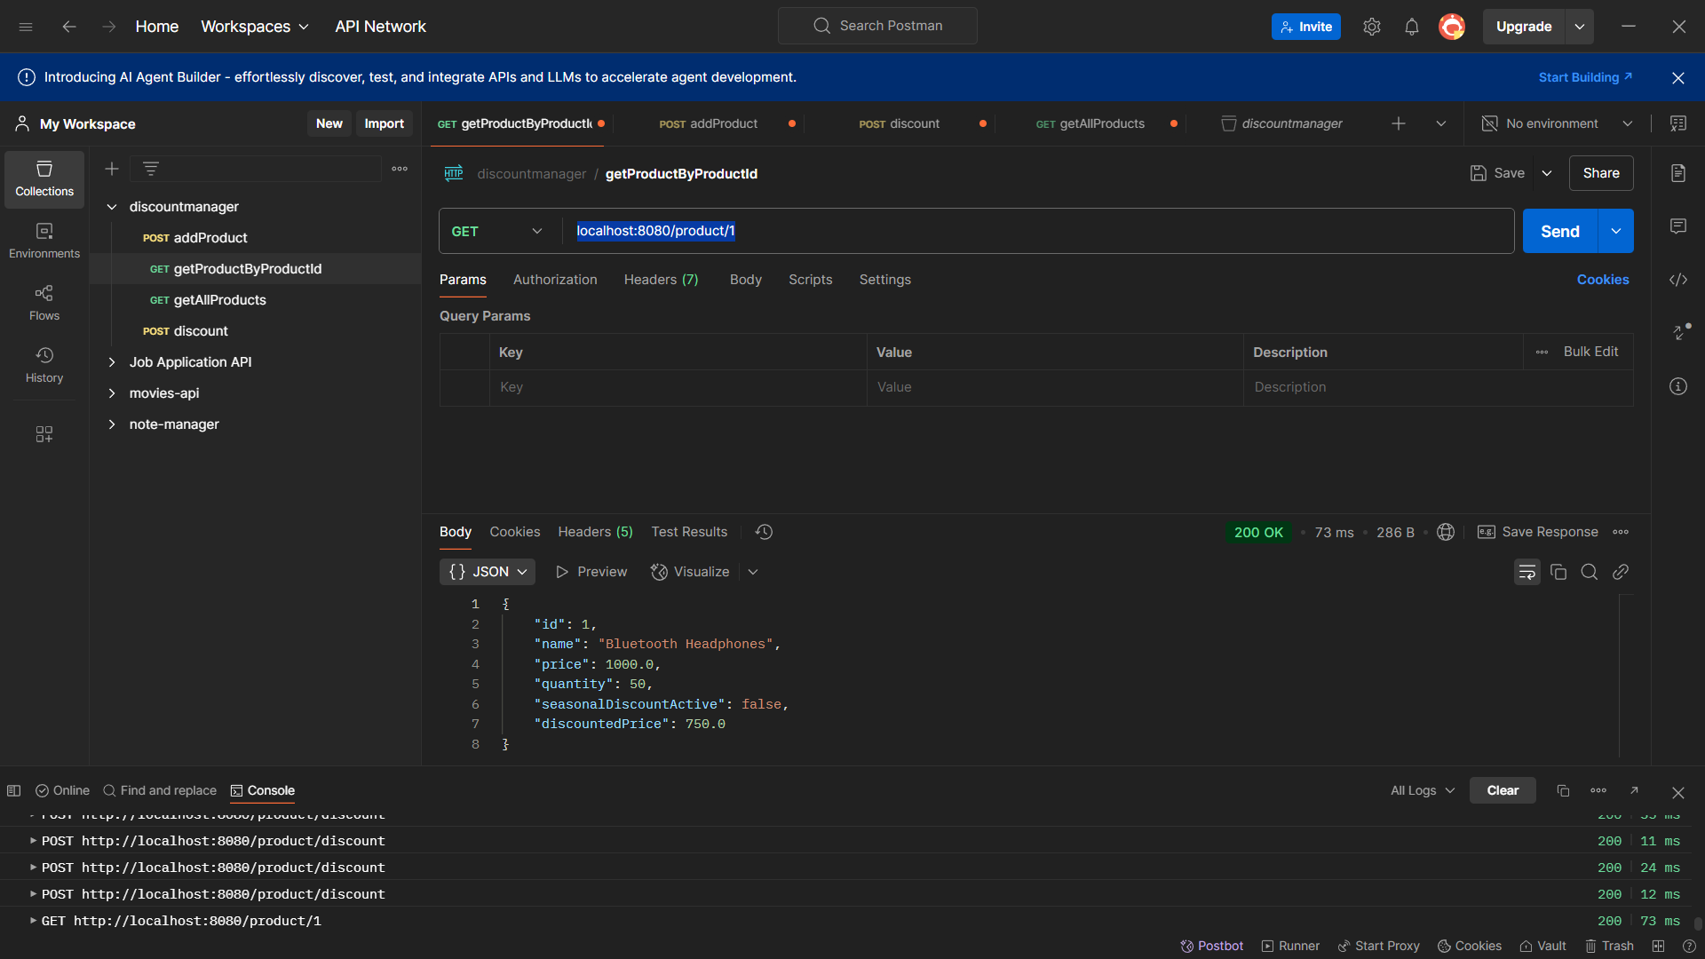

Product Not Found

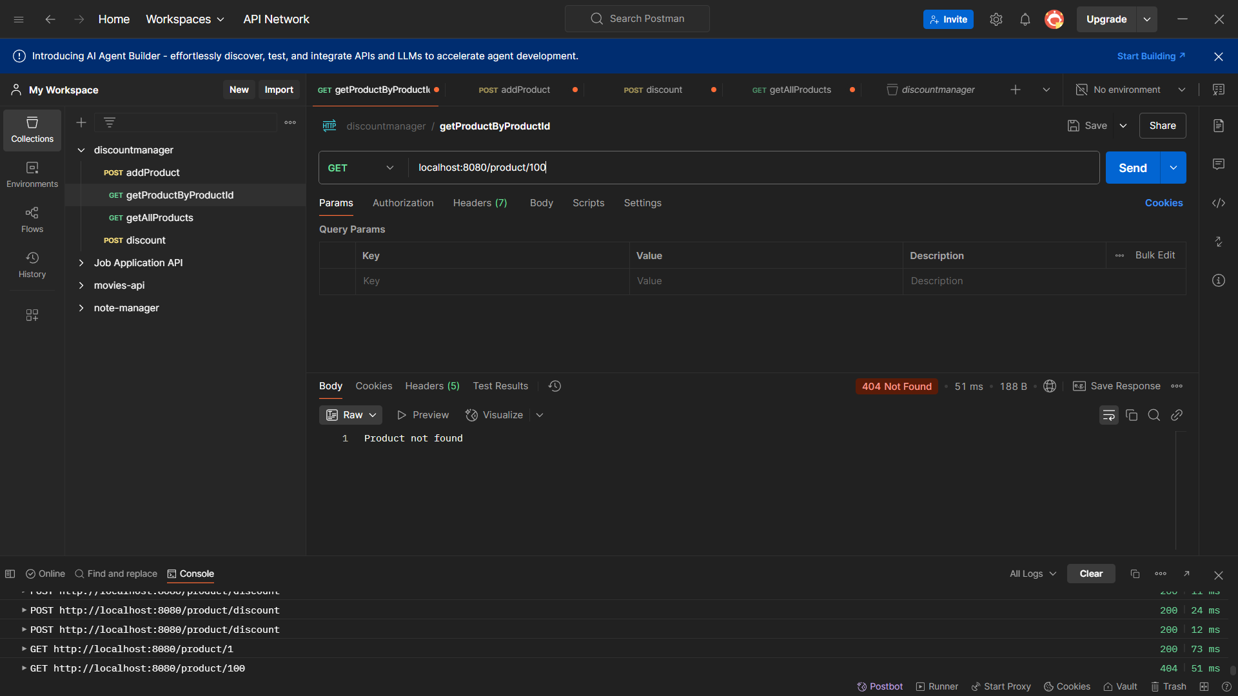

Get All products -

localhost:8080/product/all

